https://github.com/m-girl/ITAI_ML_FirstRepo_MaryAnnMastri/tree/main
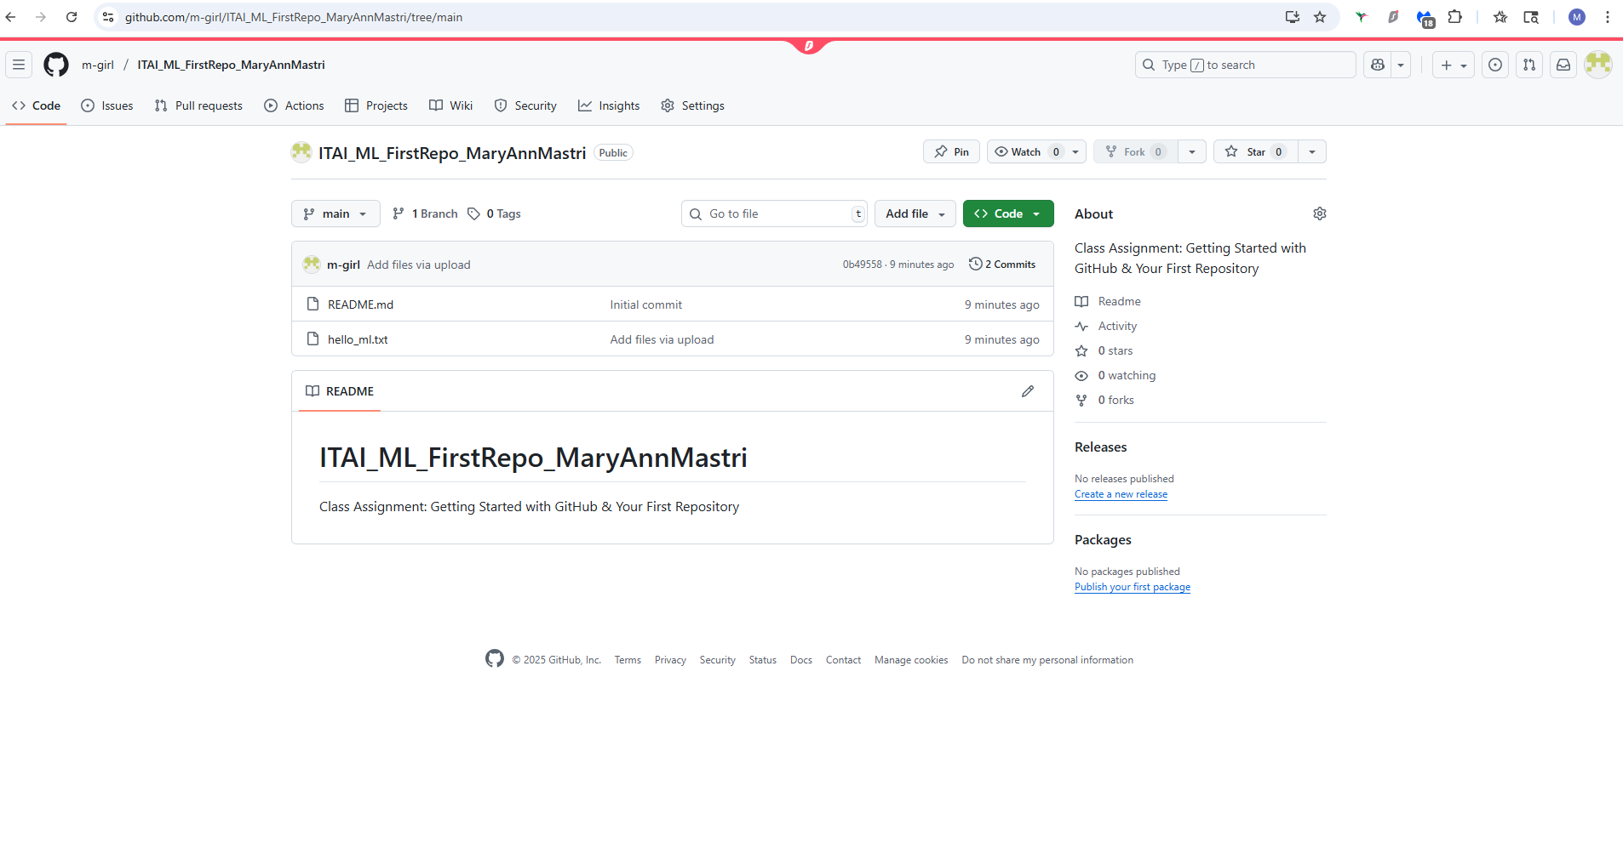

https://github.com/m-girl/ITAI_ML_FirstRepo_MaryAnnMastri/blob/main/hello_ml.txt
